Architecture Document: Expense Tracking Application
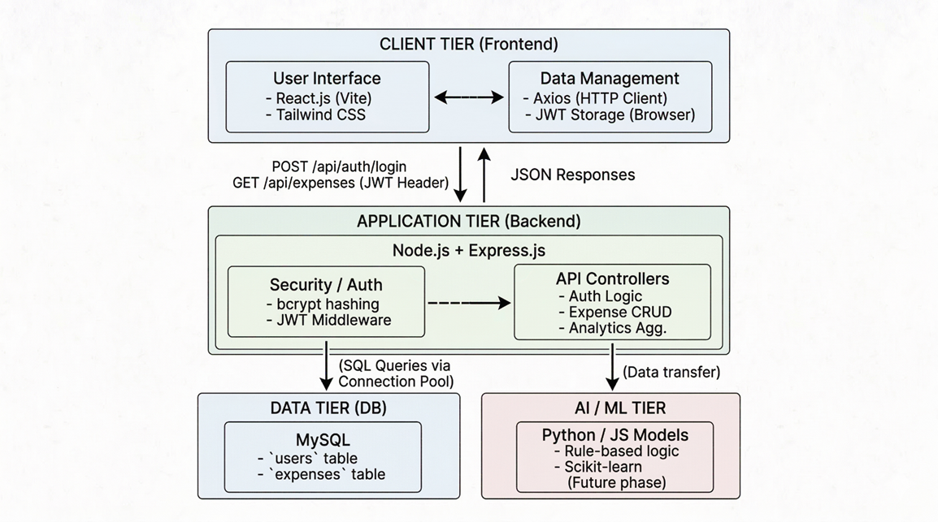
- Application Architecture
For this project, we have selected a Monolithic Architecture for the backend, operating within a broader Client-Server model. While options like Microservices, Event-Driven, or Serverless are powerful, a well-structured Monolith is highly appropriate and efficient for the current scope of an expense tracker.
Detailed Explanation:
The system is divided into two decoupled tiers: a React.js frontend (Client) and a Node.js/Express backend (Server). The backend operates as a single, cohesive unit (Monolith). All core business logic—including user authentication, expense CRUD operations, and data aggregation—is handled within this single application space. This approach simplifies deployment, testing, and debugging during the initial phases of the product lifecycle. As the application scales (e.g., introducing heavy AI processing), specific modules can be extracted into Microservices.
.
2. Database Architecture
The application relies on a robust relational database management system (MySQL) to ensure data integrity and enforce strict relationships between users and their financial records.

ER Diagram
The Entity-Relationship model is straightforward but essential:
- Entity 1: User
- Entity 2: Expense
- Relationship: A User has-many Expenses (1-to-N relationship). An Expense belongs-to one User. This relationship is enforced via a foreign key (user_id in the Expenses table).
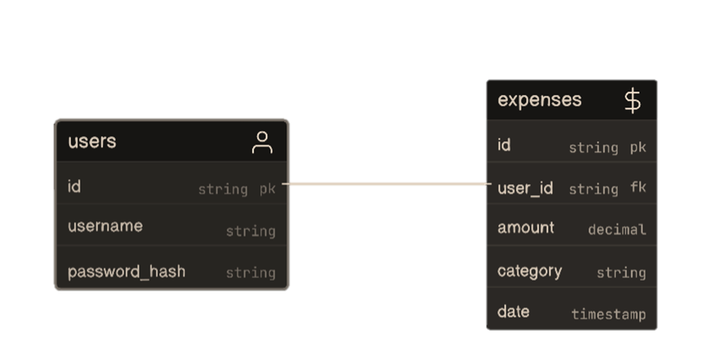
Schema Design

Table: users
Column Name | Data Type | Constraints | Description
user_id | INT | PRIMARY KEY, AUTO_INCREMENT | Unique identifier for the user.
username | VARCHAR(50) | UNIQUE, NOT NULL | User's display or login name.
password_hash | VARCHAR(255) | NOT NULL | Bcrypt hashed password for security.
created_at | TIMESTAMP | DEFAULT CURRENT_TIMESTAMP | Account creation date.
Table: expenses
Column Name | Data Type | Constraints | Description
expense_id | INT | PRIMARY KEY, AUTO_INCREMENT | Unique identifier for the expense.
user_id | INT | FOREIGN KEY (users.user_id) | Links expense to the specific user.
amount | DECIMAL(10,2) | NOT NULL | The monetary value of the expense.
category | VARCHAR(50) | NOT NULL | E.g., "Food", "Transport", "Utilities".
expense_date | DATE | NOT NULL | Date the transaction occurred.

3. Data Exchange Contract
This section defines how the Client Tier and Application Tier communicate with each other.
- Mode of Exchanges: Communication is strictly handled via RESTful APIs over HTTP/HTTPS. Data payloads are formatted as JSON. Authentication state is passed via a Bearer Token (JWT) in the HTTP Authorization header.
- Data Sets: The primary data entities exchanged include:
  - Authentication Payloads: Username and password strings (Client to Server); JWT strings (Server to Client).
  - Expense Payloads: Numeric amounts, string categories, and date values (Bidirectional).
  - Analytics Payloads: Aggregated JSON arrays representing total spending per category (Server to Client).
- Frequency of Data Exchanges: Data exchanges occur on an event-driven, as-needed basis triggered by user interactions.
  - Read frequency: Triggered upon initial page load, dashboard refresh, or applying filters.
  - Write frequency: Triggered explicitly when the user submits an "Add," "Update," or "Delete" command via the UI.
